H.T No
Regulations:
A18

Sreenidhi Institute of Science and Technology
(An Autonomous Institution)
Code No: 7A304 Date: 26-July-2021(AN)

B.Tech II-Year I- Semester Covid-19 Special External Examination, July-2021 (Regular)
ELECTRICAL CIRCUITS AND NETWORKS – II (EEE)

Time: 3 Hours Max.Marks:70

Note: a) No additional answer sheets will be provided.
b) All sub-parts of a question must be answered at one place only, otherwise it will not be valued.
c) Missing data can be assumed suitably.

ANSWER ANY 5 OUT OF 8 QUESTIONS. EACH QUESTION CARRIES 14 MARKS.

Bloom's Cognitive Levels of Learning (BCLL)

Remember | L1 | Apply | L3 | Evaluate | L5
Understand | L2 | Analyze | L4 | Create | L6

 |  |  | BCLL | CO(s) | Marks
1. | a) | Derive the relationship between a line current and phase current related to a delta connected load. | L3 | CO1 | [7M]
 | b) | Two wattmeters in a 3-ϕ, 3-wire system with an effective line voltage of 120V read 1500W and 500W. What is the impedance of each arm of the balanced delta connected load? What is the power factor of the load? | L3 | CO1 | [7M]
2. | a) | Explain the transient response of R-L-C Series circuit excited by DC Source.(Step response of R-L-C series circuit).  Use differential equation method. | L2 | CO2 | [7M]
 | b) | Find the expression for the current in a series RLC circuit fed by a DC voltage of 20V with R=4Ω, L=1H and C=1/4 F. Assume initial conditions to be zero. | L5 | CO2 | [7M]
3. | a) | Write the necessary conditions for driving point function. | L1 | CO3 | [7M]
 | b) | For the network shown in figure determine the transform impedance Z(s).  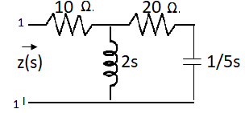 | L4 | CO3 | [7M]
4. | a) | Derive the relation to express Z-parameters interms of Y-parameters and Y-parameters interms of Z-parameters. | L4 | CO4 | [7M]
 | b) | Find transmission parameters of the network shown in the figure.  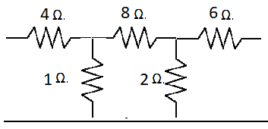 | L5 | CO4 | [7M]
5. | a) | What is a high pass filter? In what respects it is different from a low pass filter? Explain. | L2 | CO5 | [7M]
 | b) | Derive the equation to find the inductances and capacitances of a constant-K high pass filter. | L3 | CO5 | [7M]
6. |  | Calculate the Fourier series for the function shown in below figure.  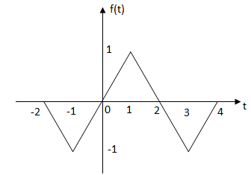 | L5 | CO6 | [14M]
7. | a) | What are the advantages of a three phase system? | L2 | CO1 | [5M]
 | b) | Find the current in a series R-L circuit having R=2Ω and L=10H while a DC. voltage of 100V is applied. What is the value of this current after 5 sec. of switching on? | L5 | CO2 | [5M]
 | c) | Draw the pole zero diagram for the given network function I(s) and hence obtain i(t).  I(s) = | L3 | CO3 | [4M]
8. | a) | Derive the condition of symmetry for Z-parameters and Y-parameters. | L3 | CO4 | [7M]
 | b) | What is filter? Define pass band, stop band and cut off frequency of filter. | L2 | CO5 | [7M]
-- 00 -- 00 –

